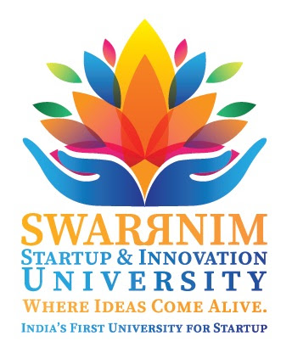

**Swarnim Startup & Innovation University Activity Report 2020**

|  |  |
| --- | --- |
| **Institute and Department** | Aarihant Homoeopathic medical college and research institute |
| **Activity Name / Event Name** | WORLD ENVIRONMENT DAY CELEBRATION AT AHMC & RI/ TREE PLANTATION DAY |
| **Date of the event** | 05/06/2021 |
| **Duration** | 3 PM TO 4 PM |
| **Semester** | BY TEACHING FACULTY & HOSPITAL STAFF |
| **Expert Details** | DR. AMITA PETERS & DR VINEETA N KUMAR |
| **Faculty Coordinator Details**  **(Name, Designation, Contact Details)** | DR. VINEETA N KUMAR  ASSITANT PROFESSOR  SURGERY  MOB : 8306190804 |
| **Numberof Participants** | 10 DOCTORS AND 2 HOSPITAL STAFF |

**Objective of the event: (why this event has organize, Brief about Importance of the event)**

1. **FOR AWARENESS ABOUT SAVING ENVIRONMENT**
2. **TO MAINTAIN THE ECO-SYSTEM OF UNIVERSITIES GARDEN**

**Flow of the event: mention the flow / schedule of the event in detail**

**PLANTS WERE ARRANGED BY HIGHER AUTHORITY AND PLANTED IN UNIVERSITIES GARDEN.**

**Conclusion:**

**ON 5/06/2020 AARIHANT HOMOEOPATHIC MEDICAL COLLEGE AND RESEARCH INSTITUTE & HOSPITAL ORGANISED A TREE PLANTATION DAY CELEBRATION AT UNIVERSITY CAMPUS. ON THIS DAY THE TEACHING FACULTIES AND THE HOSPITAL STAFF HAD ENTHUSIASTICALLY PARTICIPATED TO MAKE OUR ENVIRONMENT GREEN. WE HAD PLANTED MORE THAN 10 PLANTS IN THE CAMPUS.**

|  |
| --- |
| Photographs:  C:\Users\User\Downloads\PHOTO-2021-06-05-17-02-27.jpg  C:\Users\User\Downloads\PHOTO-2021-06-05-17-02-28.jpg  C:\Users\User\Downloads\PHOTO-2021-06-05-17-02-28 (1).jpg  C:\Users\User\Downloads\PHOTO-2021-06-05-17-02-29.jpg  C:\Users\User\Downloads\PHOTO-2021-06-05-17-02-30.jpg  C:\Users\User\Downloads\PHOTO-2021-06-05-17-02-30 (1).jpg |