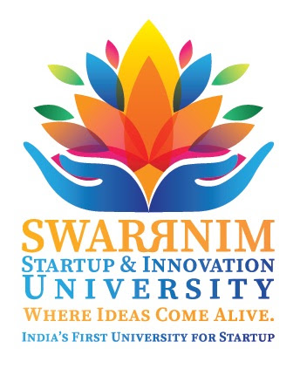

**Swarnim Startup & Innovation University Activity Report 2020**

|  |  |
| --- | --- |
| **Institute and Department** | Aarihant Homoeopathic medical college and research institute |
| **Activity Name / Event Name** | HOMOEOPATHIC AWARNESS CAMP AT SAIJ VILLEGE |
| **Date of the event** | 17/09/2020 |
| **Duration** | 10 AM TO 2 PM |
| **Semester** | BY HOSPITAL STAFF |
| **Expert Details** | DR. MANOJ KUMAR BEHERA AND DR. CHINTAN PANDYA |
| **Faculty Coordinator Details**  **(Name, Designation, Contact Details)** | DR. CHINTAN PANDYA  ASSOCIATE PROFESSOR  PRACTICE OF MEDICINE  MOB : 9824576473 |
| **Number of Participants** | 3 DOCTORS AND 3 HOSPITAL STAFF |

**Objective of the event: (why this event has organize, Brief about Importance of the event)**

**1) TO MAKE AWARNESS IN VILLEGE PEOPLE ABOUT HOMOEOPATHIC TREATMENT**

**2) TO MAKE PEOPLE BELIEVE THAT HOMOEOPATHIC TREATMENT IS HELPFULL IN CHRONIC DISORDER ALSO**

**3) TO GIVE HOMOEOPATHIC MEDICINE FOR THE PREVENTION OF COVID 19**

**Flow of the event: mention the flow / schedule of the event in detail**

**Significance/Outcome:**

**(Include questions and answer session with expert and students, what students learn from this event, include examples shared by expert faculties during the talk etc.)**

**Conclusion:**

**ON 17/09/2020 AARIHANT HOMOEOPATHIC MEDICAL COLLEGE AND RESEARCH HOSPITAL ORGANISED A CAMP AT SAIJ VILLEGE WITH THE HELP OF VILLEGE SARPANCH. ON THIS CAMP LOCAL PHC AYUSH DOCTOR ASLO HELPED US TO MAKE OUR CAMP SUCCESSFULL. WE HAD SEEN 58 PATIENT AND GIVE THEM HOMOEOPATHIC MEDICINES. WE HAD SEEN MANY PT OF PEDIATRIC DISORDERS , JOINT DISORDERS AND SKIN DISORDERS. ALONG WITH MEDICIATION WE HAD GIVEN BRIEF UNDERSTANDING ABOUT UTILITY OF HOMOEOPATHIC MEDICINES IN VARIOUS DIAORDERS. WE ALSO GAVE PREVENTIVE MEDICINES OF COVID 19 TO MANY PT AT CAMP.**

|  |
| --- |
| Photographs: |