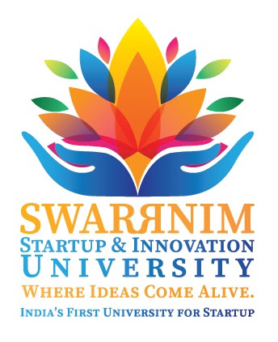

**Swarnim Startup & Innovation University Activity Report 2020**

|  |  |
| --- | --- |
| **Institute and Department** | Aarihant Homoeopathic medical college and research institute |
| **Activity Name / Event Name** | "World No Tobacco Day" celebration |
| **Date of the event** | 31/05/2020 |
| **Duration** | 1:00 P.M. TO 2:30 P.M. |
| **Semester** | 1st BHMS to final BHMS Students and teaching staff. |
| **Expert Details** | Professsor (Dr.) Manoj Kumar Behara |
| **Faculty Coordinator Details**  **(Name, Designation, Contact Details)** | Dr. Rakesh kumar Sharma  Associate professor- Community medicine  Mob : 8920205561  Dr. Shailendra Pratap Rao  Assistant professor- F.M.T  Mob : 9838111261 |
| **Number of Participants** | 137+ participants participated. Top 3 winners from 1st year to final year got E-Certificate. |

**Objective of the event: (why this event has organize, Brief about Importance of the event)**

**This event was organised to spread awareness about harmful effects of tobacco, also the purpose of this event was to spread awareness about covid-19 & effect of tobacco in covid-19 illness, to know about 'how people can prevent themselves' from covid-19 with withdrawal of tobacco chewing habit.**

**Flow of the event: mention the flow / schedule of the event in detail.**

1. **At 1:00 p.m, Webinar started by the Host- Dr Rakesh kumar Sharma & co-ordinator Dr. Shailendra Pratap Rao with Homoeopathic teaching faculty and students from first year to final year.**
2. **Welcome speech given by Dr. Shailendra Pratap Rao and processed webinar for faculties and speech competition among students.**
3. **Professor (Dr.) Manoj kumar behara was the judge of speech competition & enlightened about the bad effect of tobacco on health.**
4. **Dr Dhwanika Dhagat, Dr. Madhuri bhatt, Dr. Arohi pandey enlightened this event "world no tobacco day".**
5. **Speech competition started at 1:30 p.m. and ended at 2:20 p.m. in which 15 students took part in a speech competition & 137 plus people/students participated in this event.**
6. **Associate professor Dr. Rakesh kumar sharma highlighted and acknowledged this event and encouraged the students.**

**Significance/Outcome:**

**(Include questions and answer sessions with experts and students, what students learn from this event, include examples shared by expert faculties during the talk etc.)**

* **In this event, students from 1st year to final year learned about the bad effects of Tobacco & to spread awareness for the bad effects of Tobacco in social community.**

**Conclusion:**

* **On 31/05/2021, Aarihant homoeopathic medical college & research institute, organised a webinar on " *WORLD NO TOBACCO DAY ''*. Students enhanced their knowledge about the bad effects of Tobacco & to spread awareness for withdrawal of Tobacco chewing habits.**

|  |
| --- |
| Photographs: |